
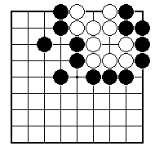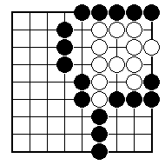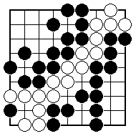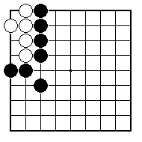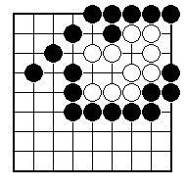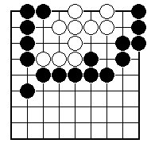
Has the white group got two eyes?

Has the white group got two eyes?

Has the white group got two eyes?

How can the white group make two eyes?

How can the white group make two eyes?

How can Black stop the white group making two eyes?

NAME:
BRITISH GO ASSOCIATION CERTIFICATE LEVEL 1 - SHEET 8

TWO EYES

